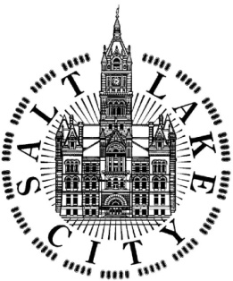
SALT LAKE CITY CORPORATION

COMMUNITY and ECONOMIC DEVELOPMENT DEPARTMENT
HOUSING and NEIGHBORHOOD DEVELOPMENT DIVISION

PUBLIC HEARING on FEDERALLY FUNDED PROJECTS

CDBG, ESG, HOME AND HOPWA PROGRAMS

WHAT: | The Salt Lake City Council seeks public comment on proposed 2020-2021 projects to be funded with federal dollars
WHEN: | Tuesday, March 24th, 2020 at 7:00 PM
WHERE: | City Council Chambers, Room 315, Salt Lake City & County Building,  451 South State Street

A public hearing will be held before the Salt Lake City Council to accept comment on proposed projects and activities to be undertaken with 2020-2021 federal funds under the following U.S. Department of Housing and Urban Development (HUD) programs:

- Community Development Block Grant (CDBG)
- Emergency Solutions Grant (ESG)
- HOME Investment Partnership Program (HOME)
- Housing Opportunities for Persons With AIDS (HOPWA)

Prior to making funding decisions on the 2020-2021 program year, the Salt Lake City Council will consider and review all comments received at the public hearing, as well as funding recommendations provided by Mayor Erin Mendenhall and citizen advisory boards. Information about funding recommendations can be found on Salt Lake City’s HAND website at www.slcgov.com/HAND.

If you are unable to attend the hearing and want your voice to be heard, written comments may be submitted to Tony.Milner@slcgov.com. Comments will also be accepted by the Salt Lake City Council office at 451 South State Street, Room 304, PO Box 145476, Salt Lake City, Utah 84111, or emailed to council.comments@slcgov.com. Additionally, messages may be left on the Council comment telephone number; 801-535-7654. Comments must be submitted by March 31, 2020.

EQUAL OPPORTUNITY PROGRAM
People with disabilities may make requests for reasonable accommodation no later than 48 hours in advance in order to attend this public meeting. Accommodations may include alternate formats, interpreters, and other auxiliary aids. This is an accessible facility. Salt Lake City Corporation is committed to ensuring we are accessible to all members of the public. To request ADA accommodations contact Sarah Benj by email at sarah.benj@slcgov.com or by phone at 801.535.7697.

