Dewatering Control Plan (DCP) Template Instructions:

DWQ has developed this template for dewatering and hydrostatic testing sites permitted under the General Permit for Construction Dewatering and Hydrostatic Testing (CDHT). The template gives you a framework to ensure that your DCP addresses the necessary elements required by the permit.
This template covers most of the DCP elements that the Utah CDHT requires, however, you are encouraged to customize this template to reflect unique conditions at the site or address a requirement not covered in the provided sections.

Dewatering Control Plan
for:
Insert Project Name
Insert Project Site Location/Address
Insert City, State, Zip Code
Insert Project Site Telephone Number (if applicable)

Operator:
Insert Company or Organization Name
Insert Name
Insert Address
Insert City, State, Zip Code
Insert Telephone Number
Insert Fax/Email

Primary DCP Contact:
Insert Company or Organization Name
Insert Name
Insert Address
Insert City, State, Zip Code
Insert Telephone Number
Insert Fax/Email

DCP Preparation Date:
__/__/__

UPDES Permit Tracking Number*:
UTG-________

*This is the unique number assigned to your project after you have applied for coverage under the Utah Pollutant Discharge Elimination System (UPDES) construction dewatering and hydrostatic testing permit. If this template is filled out first, you can leave the tracking number blank until after you have applied for coverage.

Table of Contents
Section 1: Contact Information/Responsible Parties 4
Section 2: Nature of Construction Activities 4
Section 3: Nature of Dewatering Activities 4
Section 4: Dewatering Best Management Practices (BMPs) 6
Section 5: Inspections and Sampling 8

Section 1: Contact Information/Responsible Parties
  - Instructions: Identify Responsibilities
Responsibilities | Name/Position
Obtain and Maintain CDHT Coverage | Insert name and contact information
DCP Creation and Maintenance | Insert name and contact information
Daily Visual Inspections | Insert name and contact information
Weekly Sampling | Insert name and contact information

Section 2: Nature of Construction Activities
2.1 Construction Activities
Is there a Construction General Permit or Common Plan Permit associated with this project?
If so, insert permit number here _____________
☐Check box if section not applicable to this site

Section 3: Nature of Dewatering Activities
3.1 Dewatering Activity
Instructions: Please check which dewatering activity is applicable to your site. Note: Any dewatering discharge that is land applied and does not reach state waters or the storm drain is not regulated under the CDHT permit however a groundwater permit may be required.

☐ In-stream dewatering: cofferdams, drill hole or pylon development
☐ Surface area dewatering: water pumped from disturbed surface areas (trenches, sumps, excavation pits, or other excavations associated with construction where sediment-laden ground water or surface water/storm inflow must be removed)
☐ Ground water dewatering: water discharged from well development, well pump tests, or pumping of ground water from a construction area. Dewatering wells located within an active area of disturbance is subject to the Construction Dewatering/Hydrostatic Testing General Permit. Common methods of ground water dewatering from a construction area include sumps, wells, and well-points.
☐ Hydrostatic Testing: such as piping systems, gas cylinders, fire extinguishing, storage tanks, boilers, chemical pipelines, and pressure vessels that are tested for strength and leaks.

3.2 Dewatering Discharge Locations
Instructions: Identify the locations of each dewatering discharge (CDHT II.F.2)). If discharging at multiple locations, identify the timeframe of discharging activities for each discharge location. If discharging at multiple locations, identify a short hand name for the discharge locations (i.e., A, B, C, etc.). Please identify the duration of dewatering in days or weeks, and identify the estimated maximum flow volumes for each discharge (CDHT I.D.6.). Please identify the units of your calculations. Use additional rows if needed.

Name of Discharge Locations | GPS of Discharge Location | Timeframe of Dewatering | Estimated Maximum flow

Instructions: Identify the receiving water for each dewatering discharge location (CDHT I.D.3.a.). Identify if the receiving waterbody has any impairments. If so, identify each impairment in the table below. Use additional rows if needed. Please use this map for a list of waterbodies and their impairments: https://enviro.deq.utah.gov/

Name of Discharge Location | Receiving Water | Receiving Water Impaired? (y/n) | If impaired, identify impairment(s)

Section 4: Dewatering Best Management Practices (BMPs)
4.1 BMPs to prevent high Total Suspended Solids (TSS)
Instructions: Please list any BMPs utilized for preventing high TSS in the dewatering discharge. Each BMP should have flow specifications (maximum flow volume that the BMP is specified for) to ensure that BMPs are chosen appropriately for the anticipated flow volume (CDHT Sections I.D.6. & II.F.3)a.). BMPs listed in the table below should identify controls for minimizing TSS. Ensure the BMPs are sufficient to handle the initial purge, or identify alternative BMPs for the initial purge discharge in the below table.

Name of Discharge Location | BMPs Utilized | Maximum Flow Capacity of BMP  (if applicable)

4.2 BMPs to Minimize Erosion
Instructions: Please list any BMPs associated with minimizing erosion, scouring, or damage to stream banks, streambeds, or ditches (CDHT Sections I.D.8. & I.D.7.).
☐Check box if section not applicable to this site.
Please explain:________________________________________________________________________

Name of Discharge Location | BMPs Utilized | Maximum Flow Capacity of BMP  (if applicable)

4.3 BMPs for Pollution Prevention
Instructions: Please list each BMP associated with protecting both the source and point of discharge from unlawful contaminants that are not authorized by the permit prior to discharge into waters of the state (CDHT I.C.). Factors to consider in this list include: Spilled or leaking fuels entering into the watercourse, Excess sediment entering or being transported down the watercourse, etc. This section may not be applicable if your dewatering discharge is pumped directly into a storm drain or won’t interact with outside contaminants along the watercourse prior to connecting with the water of the state.

☐ Check box if this section doesn’t apply to your site, delete the table below, and explain why it doesn’t apply.
Please explain: _________________________________________________________________

Name of Discharge Locations | BMPs Utilized | Maximum Flow Capacity of BMP  (if applicable)

Section 5: Inspections and Sampling
5.1 Daily Log Inspections
Please see Appendix A for a Template for Daily Log observations (CDHT Section II.G.) and Discharge Log observations (CDHT Section II.F.) combined.

5.2 Discharge Log & Discharge Map
Please see Appendix A for a Template for Daily Log observations (CDHT Section II.G.) and Discharge Log observations (CDHT Section II.F.) combined.
Please attach a map showing the discharge locations (CDHT II.F.2)). This should be a general map of the site with each discharge point identified.

Attach map here

5.3 Sampling
Please take weekly samples from each discharge point. Samples should be taken at the furthest downstream BMP of each discharge point (i.e., if you have a filter bag over your discharge hose, take a sample of the water after it has filtered through the bag). Sample results should be submitted for each discharge location to DWQ monthly no later than the 28th day of the month. If no discharge occurs, “No Discharge” should be reported.

Please follow the following considerations: pH must be analyzed within 15 minutes (CDHT I.D.1.h.). Oil and grease must be sampled if a visible sheen is observed (CDHT I.D.1.c.). Chlorine is only required for Hydrostatic Testing cases that chlorinated water is used and discharged to a stream with a chlorine standard (CDHT I.D.1.f.).

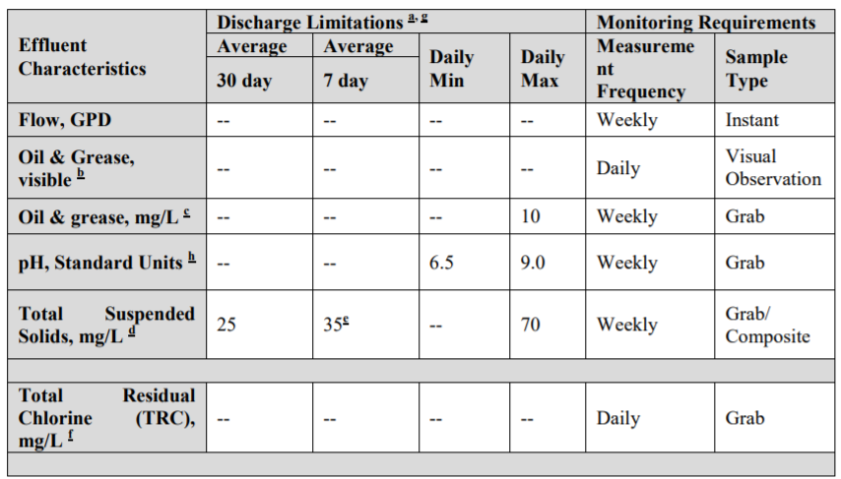

5.4 Noncompliance Procedures
Upon any visual observation of Best Management Practices (BMPs) failure, inadequate BMPs, elevated turbidity, or an oil sheen, the following steps must be conducted:
- Take a grab sample for analysis anytime there is an observation of elevated turbidity and/or oil and grease.
- Cease discharge of dewatering effluent until the issue is resolved.
- Conduct a site-wide inspection to observe operating conditions and BMP maintenance.
- Address any BMP failures by determining whether there was a failure in design, installation, or maintenance and perform the appropriate measures to fix the failure, including determining whether BMPs should be modified or if additional measures must be taken.
- Document the issue and resolutions in the daily log and update the Dewatering Plan.
- Notify the Division of Water Quality.
  - To report incidents “Initial Non-Compliance Notification” form is available. See Appendix G of the CDHT Permit.
- Include a report with the next DMR submittal.

Appendix A
Please utilize this template for the daily observations required for the CDHT permit. Please complete a form for each discharge location.
Note: Sample visual or grab indicates whether weekly sampling was conducted on this day (grab sample) or whether visual observations were documented. Grab samples require that all columns completed. Visual samples require every column except columns for flow and flow units are completed. If problems observed column is checked yes, please initiate non-compliance procedures found in Section 5.4.
Discharge Log & Daily Observations
Name of Discharge Location:
Date | Start Time | End Time | Sample:  Visual/Grab | Flow | Flow Units | Oil/Grease Sheen? (y/n) | Inspection Observation? i.e., odor, color, sheen, erosion at discharge location, etc. | Problems Observed? (y/n) | Initials

